TECHNICAL SERVICE BULLETIN

Product: Enduro 200 & 250, Duraflex 200 & 250

Subject: New Agitator Gear Motor Assembly.

Date: 2/21/2023

Description:

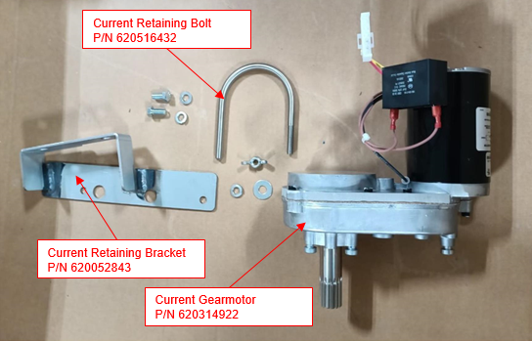
Effective March 7th 2023 we will be implementing a new agitator gear motor assembly. As part of the rollout, we are also releasing a new retaining bolt and retaining bracket to accommodate the larger motor diameter.

The new SPG gear motor assembly design allows for the removal of the motor while leaving the gearbox in place. Significantly reducing the replacement time in situations where motor failure is the root cause.

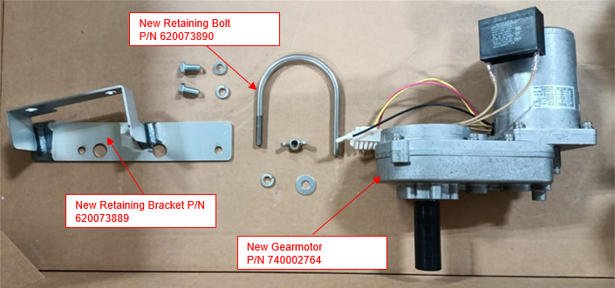
All service technicians looking to replace the existing Bison gear motor assembly going forward should purchase service kit 740002799. As this kit provides the gear motor assembly along with the new retaining bolt 620073890 and retaining bracket 620073889 and spare mounting hardware.

The Bison gear motor can be distinguished in the field from the SPG version by their identification labels as well as the color of the motor barrel. As the original Bison gear motors uses a Black painted barrel while the new SPG gear motors uses an unpainted aluminum barrel.

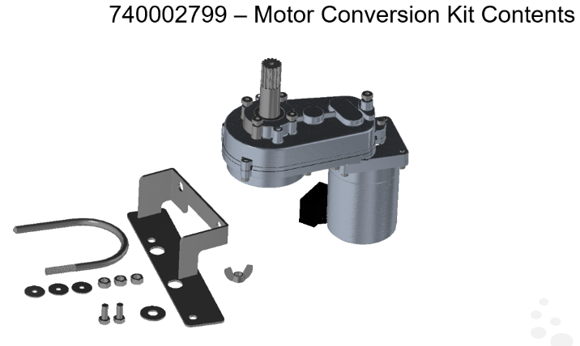
In a situation where a technician needs to replace the new SPG Gear motor assembly, we are offering conversion kit 629088782. This kit contains only the SPG gear motor assembly with the pre-installed mounting bolts.

Finally, since the SPG design allows the motor to be serviced separately from the gearbox we are also releasing the motor by itself under P/N 740002802.

